2019 Admission Requirements
of Yangling Vocational and Technical College
1. Admission plan
15 spots are available in 2019, with scholarship
2. Applying requirements
A. Non-Chinese nationality
B. In good health and no criminal record
C. With high school graduation certificate
D. Candidates with basic Chinese are preferred
E. Candidates with basic knowledge of Chinese society, economy and culture are preferred
F. With good family financial status to support living and travelling expenses during study period
3. Diploma programs
E-commerce, logistics management, agricultural biotechnology, hydraulic engineering
4. Duration and academic term
A. Duration of diploma program: 3 years, 2 terms in one academic year;
New school year starts from September every year
B. Spring term: march – June (July and august are summer holiday)
C. Autumn term: September – December (January and February are winter holiday)
5. Teaching plan
A. 1st school year: Chinese (major), specific program (minor); 2nd and 3rd school year: specialty courses, professional skills courses and practice courses
B. Qualified graduates will obtain college diploma certificate written in both Chinese and English.
6. Fees and facilities
A. Fees:
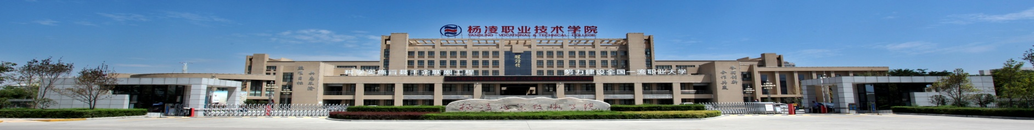
The college provides presidential scholarship to qualified candidates. The scholarship will not be issued in cash but in the form of fee exemption (tuition fees, dormitory fees and insurance fees) for equivalent amount in three academic years. Other expenses and fees incurred during study period is afforded by students themselves, for instance, living expenses, travelling expenses, physical examination, residence permit certificate, etc.
B. Dormitory: 3 people in one room; facilities in dormitory include bathroom (with shower), air conditioner, beds, beddings, wardrobes, and desks. Public kitchen (induction cookers, microwave ovens) and public laundry are outside dormitory in apartment.
C. Student canteen has halal food dining area. Students shall use student card in canteen. Monthly food expense in canteen is around 800 Yuan.
7. Application and enrollment:
A. Please email the following application materials to ylvtc1934@163.com and all documents must be scanned and converted into pdf format.
- Admission application form (download at http://gjxy.ylvtc.cn/info/1052/1361.htm; save the doc with name and send the word and pdf format to the college email)
- High school graduation certificates (English or Chinese translation version must be notarized if the original paper is not written in English or Chinese)
- Transcripts (English or Chinese translation version must be notarized if the original paper is not written in English or Chinese)
- Passport (the page with personal information)
- Physical examination record (English or Chinese translation version must be notarized if the original paper is not written in English or Chinese)
- Certificate of no criminal record (English or Chinese translation version must be notarized if the original paper is not written in English or Chinese)
b. Qualified candidates will receive letter of admission and form of visa application for study in china (jw202 form) for visa application purpose. Candidate who fails to complete registration process at the college 2 weeks after the admission date will not be accepted by the college.
8. Contact us
Tel: 0086 — 029 — 87083330
Website: http://www.ylvtc.cn/ (Chinese)
http://gjxy.ylvtc.cn/english.htm (English)
Email: ylvtc1934@163.com
Address: no. 24 Weihui Rd., Yangling, Shaanxi Province, P. R .China. 712100

